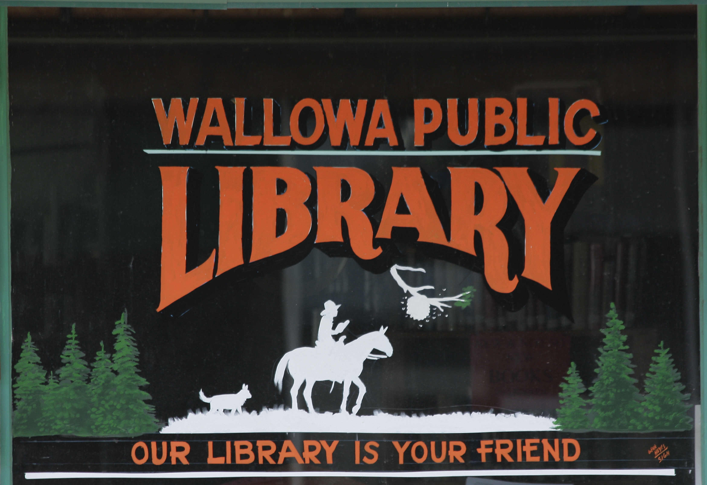

Wallowa Public Library helps the community share information by providing bulletin boards and designated areas (such as literature racks and spaces on countertops and tables) for posting and distribution. These spaces may be used by outside groups to promote events and services of interest to the library’s patrons. These areas are considered limited public forums and thus are open to any legal content or viewpoint, with restrictions noted in this policy.

Bulletin Boards and Distribution Areas
Bulletin boards and distribution areas are available within the library to post and distribute materials from outside organizations. Bulletin board space is provided for dated materials such as posters or signs of interest to the library’s patrons. Distribution space is provided in designated areas for materials such as small posters, brochures, and handouts. Materials may be left for patrons to review and take, if they choose, but such distribution shall not include verbally or visually (by means of signs, placards, etc.) encouraging patrons to review or take any materials with them.
Designated areas include public use bulletin boards, window space on the eastern most window, and literature racks at library where space permits. Posting and distribution of items by outside groups (i.e. not the library, its Friends of the Library, or partnering organizations) is limited to these designated areas.

Limitations
The following items may not be posted on bulletin boards or left in material distribution areas:
- Materials advertising commercial services or products.
- Materials that support or oppose any current or pending ballot measure or political candidate. The Library is not intended to be a forum for the support or opposition of political candidates or ballot measures. Official election information from government or nonpartisan agencies may be made available in the Library for a reasonable period prior to elections.
- Materials asking Library visitors to sign a petition or letter.

Posting or distribution of materials from the library facility do not indicate Library endorsement of the ideas, issues, organizations, or events promoted by those materials. Because space is limited, library staff reserve the right to remove materials that are larger than 11” by 17”, have been up for more than one month, are not applicable to local region, or generally prevent equitable use of space.
Materials that do not comply with this policy also shall be removed.
The Library assumes no responsibility for the preservation or protection of materials. Materials will not be returned. The Library does not allow posting materials that are obscene, libelous, threatening, defamatory, harassing, violate intellectual property laws, or advocate illegal activity, as defined by relevant laws.

Policy Established: November 13, 2023

_______________________________
Library Board Chair/date

________________________________
Library Director/date

